School of Science, Computing and Engineering Technologies

COS30045

LAB 4.1 Design Studio

Overview

In this lab you will be given a sample data set and asked to identify the different data and attribute types. You will also think about some questions about this data set that might be answered by a visualisation.

ardd_fatalities_Jan2020_0.xlsx (download from Canvas)

Download and review this data set before attempting this exercise.

1 Interpreting the data set

Complete the LAB 4.1 Quiz.

2 Visualisation Design

Think of three questions you would like to answer with that require a data visualisation.

For each data question you will need to consider the following:

Which data attributes (columns) do you need to answer this question?

Do you need to transform any of the data?

Does the data type change when you transform the data? If so how.

Make a sketch of how you think your visualisation might look and add to this document.

1. **What is the distribution of crash types (Pedestrian, Single, Multiple) across different months of the year?**

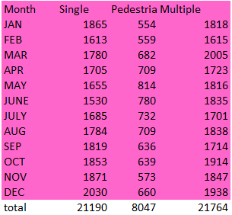

* **Data attributes needed**: Crash Type, Month
* **Transformation**: You might need to categorize the crash types into the three categories (Pedestrian, Single, Multiple) if they aren’t already grouped. The data will likely remain categorical for crash types and temporal for the months.
* **Suggested visualization**: A stacked bar chart, where each bar represents a month, and the sections of each bar represent the different crash types.

1. **How has the number of crashes involving different genders changed over time (1989–2020)?**



* **Data attributes needed**: Gender, Year of Crash
* **Transformation**: Group the data by 10-year intervals to simplify visualization. The year will remain numerical, but gender data could be categorical (e.g., Male, Female, Other/Unknown).
* **Suggested visualization**: A grouped bar chart, with each group representing a 10-year interval, and bars within each group showing the count of crashes for each gender.

1. **How does the number of crashes differ between weekdays and weekends over time (1989–2020)?**

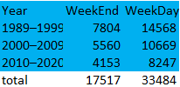

* **Data attributes needed**: Day of the Week, Year of Crash
* **Transformation**: You can categorize the days into two groups: weekdays (Monday–Friday) and weekends (Saturday–Sunday). The day of the week will be transformed from a specific day to a binary category (Weekday/Weekend).
* **Suggested visualization**: A line graph showing the number of crashes for weekdays and weekends over the years, with two lines representing each category.